***GRAMMAR LESSON***

1. **Выполните тесты по теме « Условные предложения». Ответы занесите в таблицу. Отправьте преподавателю.**

**TESTS 3, 4**

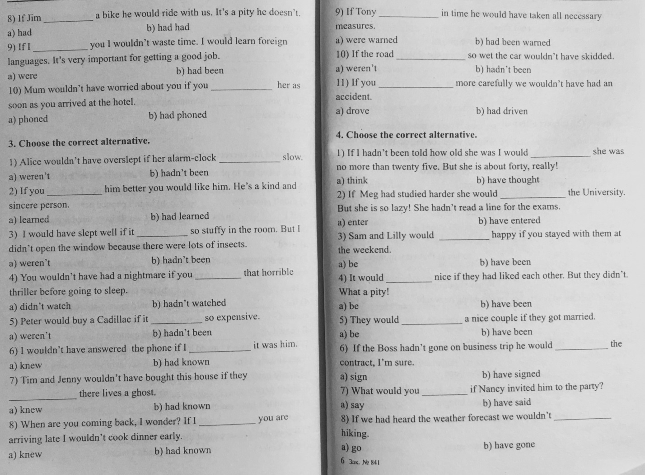

**TEST 3:**

|  |  |  |  |  |  |  |  |  |  |  |
| --- | --- | --- | --- | --- | --- | --- | --- | --- | --- | --- |
| 1 | 2 | 3 | 4 | 5 | 6 | 7 | 8 | 9 | 10 | 11 |
| b | a | b | b | a | b | b | a | b | b | b |

**TEST 4:**

|  |  |  |  |  |  |  |  |
| --- | --- | --- | --- | --- | --- | --- | --- |
| 1 | 2 | 3 | 4 | 5 | 6 | 7 | 8 |
| b | a | a | b | a | b | a | b |

1. **Выполните тест 5 (начиная с 3 предложения). Ответы занесите в таблицу. Найдите ошибки в упражнении 4 и правильно перепишите предложения**. **Отправьте преподавателю.**

**Test 5:**

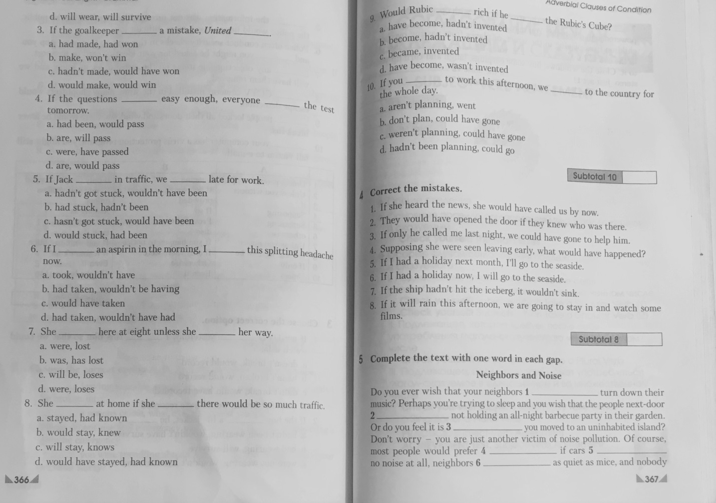

**Test 5:**

|  |  |  |  |  |  |  |  |
| --- | --- | --- | --- | --- | --- | --- | --- |
| 3 | 4 | 5 | 6 | 7 | 8 | 9 | 10 |
| c | b | a | b | c | d | b | d |

**Correct the mistakes:**

|  |
| --- |
| **1 If she had heard the news, she would have called us by now.** |
| **2 They would have opened the door if they had known who was there.** |
| **3 If only he had called me last night, we could have gone to help him.** |
| **4 Supposing she had benn seen leaving early, what would have happened ?** |
| **5 If I have a holiday next month, I will go to the seaside.** |
| **6 IF I have a holiday now, I will go to the seaside.** |
| **7 If the ship was not hit the iceberg, it wouldn't have sunk** |
| **8 If it will rains this afternoon, we are going to stay in and watch some films.** |